**PRACTICAL 1**

**AIM: Introduction to Android.**

**History:**

Android, Inc. was founded in [Palo Alto, California](http://en.wikipedia.org/wiki/Palo_Alto,_California) in October 2003 by [Andy Rubin](http://en.wikipedia.org/wiki/Andy_Rubin) (co-founder of [Danger](http://en.wikipedia.org/wiki/Danger_(company))), [Rich Miner](http://en.wikipedia.org/wiki/Rich_Miner) (co-founder of Wildfire Communications, Inc.), Nick Sears (once VP at [T-Mobile](http://en.wikipedia.org/wiki/T-Mobile_USA)), and Chris White (headed design and interface development at [WebTV](http://en.wikipedia.org/wiki/WebTV)) to develop, in Rubin's words "smarter mobile devices that are more aware of its owner's location and preferences".

**What is android?**

Android is a software stack for mobile devices that includes an operating system, middleware and key applications. Android is a [mobile operating system](http://en.wikipedia.org/wiki/Mobile_operating_system) (OS) based on the [Linux kernel](http://en.wikipedia.org/wiki/Linux_kernel) that is currently developed by [Google](http://en.wikipedia.org/wiki/Google). With a [user interface](http://en.wikipedia.org/wiki/User_interface) based on [direct manipulation](http://en.wikipedia.org/wiki/Direct_manipulation_interface), Android is designed primarily for [touchscreen](http://en.wikipedia.org/wiki/Touchscreen) mobile devices such as [smartphones](http://en.wikipedia.org/wiki/Smartphone) and [tablet computers](http://en.wikipedia.org/wiki/Tablet_computer), with specialized user interfaces for televisions ([Android TV](http://en.wikipedia.org/wiki/Android_TV)), cars ([Android Auto](http://en.wikipedia.org/wiki/Android_Auto)), and wrists ([Android Wear](http://en.wikipedia.org/wiki/Android_Wear)). The OS uses touch inputs that loosely correspond to real-world actions, like swiping, tapping, pinching, and reverse pinching to manipulate on-screen objects, and a [virtual keyboard](http://en.wikipedia.org/wiki/Virtual_keyboard). Despite being primarily designed for touchscreen input, it also has been used in [game consoles](http://en.wikipedia.org/wiki/Video_game_console), [digital cameras](http://en.wikipedia.org/wiki/Digital_camera), and other electronics.

**Features of Android:**

* **Messaging**
  + [SMS](http://en.wikipedia.org/wiki/SMS) and [MMS](http://en.wikipedia.org/wiki/Multimedia_Messaging_Service) are available forms of messaging, including threaded [text messaging](http://en.wikipedia.org/wiki/Text_messaging) and [Android Cloud To Device Messaging](http://en.wikipedia.org/wiki/Android_Cloud_To_Device_Messaging) (C2DM) and now enhanced version of C2DM, Android [Google Cloud Messaging](http://en.wikipedia.org/wiki/Google_Cloud_Messaging) (GCM) is also a part of Android Push Messaging service.
* **Web browser**
  + The web browser available in Android is based on the open-source [Blink](http://en.wikipedia.org/wiki/Blink_(layout_engine)) (previously [WebKit](http://en.wikipedia.org/wiki/WebKit)) layout engine, coupled with [Chrome](http://en.wikipedia.org/wiki/Google_Chrome)'s [V8 JavaScript engine](http://en.wikipedia.org/wiki/V8_JavaScript_engine). The browser scores 100/100 on the [Acid3](http://en.wikipedia.org/wiki/Acid3#Mobile_browsers)test on Android 4.0.
* **Voice based features**
  + Google search through voice has been available since initial release. Voice actions for calling, texting, navigation, etc. are supported on Android 2.2 onwards. As of Android 4.1, Google has expanded Voice Actions with the ability to talk back and read answers from Google's Knowledge Graph when queried with specific commands. The ability to control hardware has not yet been implemented.
* **Multi-touch**
  + Android has native support for [multi-touch](http://en.wikipedia.org/wiki/Multi-touch) which was initially made available in handsets such as the [HTC Hero](http://en.wikipedia.org/wiki/HTC_Hero). The feature was originally disabled at the kernel level (possibly to avoid infringing Apple's patents on touch-screen technology at the time). Google has since released an update for the [Nexus One](http://en.wikipedia.org/wiki/Nexus_One) and the [Motorola Droid](http://en.wikipedia.org/wiki/Motorola_Droid) which enables multi-touch natively.
* **Multitasking**
  + Multitasking of applications, with unique handling of memory allocation, is available.
* **Screen capture**
  + Android supports capturing a [screenshot](http://en.wikipedia.org/wiki/Screenshot) by pressing the power and volume-down buttons at the same time. Prior to Android 4.0, the only methods of capturing a screenshot were through manufacturer and third-party customizations or otherwise by using a PC connection (DDMS developer's tool). These alternative methods are still available with the latest Android.
* **Video calling**
  + Android does not support native video calling, but some handsets have a customized version of the operating system that supports it, either via the [UMTS](http://en.wikipedia.org/wiki/UMTS) network (like the [Samsung Galaxy S](http://en.wikipedia.org/wiki/Samsung_Galaxy_S)) or over IP. Video calling through Google Talk is available in Android 2.3.4 and later. Gingerbread allows [Nexus S](http://en.wikipedia.org/wiki/Nexus_S) to place Internet calls with a SIP account. This allows for enhanced VoIP dialing to other SIP accounts and even phone numbers. Skype 2.1 offers video calling in Android 2.3, including front camera support. Users with the [Google+ Android app](https://play.google.com/store/apps/details?id=com.google.android.apps.plus&hl=en) can video chat with other google+ users through [hangouts](http://www.google.com/+/learnmore/hangouts/).
* **Multiple language support**
  + Android supports multiple languages.
* **Accessibility**
  + Built in text to speech is provided by *Talk back* for people with low or no vision. Enhancements for people with hearing difficulties are available as are other aids.
* **Connectivity**
  + Android supports connectivity technologies including [GSM](http://en.wikipedia.org/wiki/GSM)/[EDGE](http://en.wikipedia.org/wiki/Enhanced_Data_Rates_for_GSM_Evolution), [Wi-Fi](http://en.wikipedia.org/wiki/Wi-Fi), [Bluetooth](http://en.wikipedia.org/wiki/Bluetooth), [LTE](http://en.wikipedia.org/wiki/LTE_Advanced), [CDMA](http://en.wikipedia.org/wiki/Code_division_multiple_access), [EV-DO](http://en.wikipedia.org/wiki/Evolution-Data_Optimized), [UMTS](http://en.wikipedia.org/wiki/Universal_Mobile_Telecommunications_System), [NFC](http://en.wikipedia.org/wiki/Near_field_communication), [IDEN](http://en.wikipedia.org/wiki/Integrated_Digital_Enhanced_Network) and [WiMAX](http://en.wikipedia.org/wiki/WiMAX).
* **Bluetooth**
  + Supports voice dialing and sending contacts between phones, sending files ([OPP](http://en.wikipedia.org/wiki/Object_Push_Profile)), accessing the phone book ([PBAP](http://en.wikipedia.org/wiki/Bluetooth_profile#Phone_Book_Access_Profile_.28PBAP.2C_PBA.29)), [A2DP](http://en.wikipedia.org/wiki/A2DP) and [AVRCP](http://en.wikipedia.org/wiki/AVRCP). Keyboard, mouse and joystick ([HID](http://en.wikipedia.org/wiki/Bluetooth_profile#Human_Interface_Device_Profile_.28HID.29)) support is available in Android 3.1+, and in earlier versions through manufacturer customizations and third-party applications.
* **Tethering**
  + Android supports [tethering](http://en.wikipedia.org/wiki/Tethering), which allows a phone to be used as a wireless/wired [Wi-Fi hotspot](http://en.wikipedia.org/wiki/Wi-Fi_hotspot). Before Android 2.2 this was supported by third-party applications or manufacturer customizations.

**Architecture of Android:**

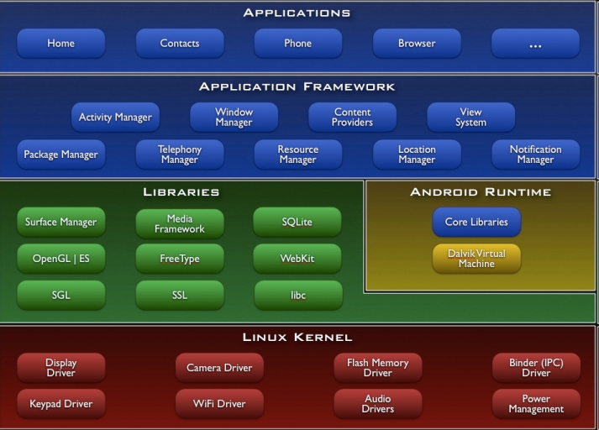

**Application:**

These are the basics of Android applications:

•      Android applications are composed of one or more application components (activities, services, content providers, and broadcast receivers)

•      Each component performs a different role in the overall application behavior, and each one can be activated individually (even by other applications)

•      The manifest file must declare all components in the application and should also declare all application requirements, such as the minimum version of Android required and any hardware configurations required

•      Non-code application resources (images, strings, layout files, etc.) should include alternatives for different device configurations (such as different strings for different languages)

**Versions of Android:**

* Android 1.0
* Android 1.1
* Android 1.5 Cupcake
* Android 1.6 Donut
* Android 2.0 Eclair
* Android 2.0.1 Eclair
* Android 2.1 Eclair
* Android 2.2–2.2.3 Froyo
* Android 2.3–2.3.2 Gingerbread
* Android 2.3.3–2.3.7 Gingerbread
* Android 3.0 Honeycomb
* Android 3.1 Honeycomb
* Android 3.2 Honeycomb
* Android 4.0–4.0.2 Ice Cream Sandwich
* Android 4.0.3–4.0.4 Ice Cream Sandwich
* Android 4.1 Jelly Bean
* Android 4.2 Jelly Bean
* Android 4.3 Jelly Bean
* Android 4.4 KitKat

**Advantages of Android:**

1. Android is open, because it is linux based open source so it can be developed by anyone.
2. Easy access to the Android App Market: Android owners are people who love to learn the phone, with Google's Android App Market you can download applications for free.
3. Populist Operating System: Android Phones, different from the iOS is limited to the iphone from Apple, then Android has many manufacturers, with their respective flagship gadget from HTC to Samsung.
4. USB full facilities. You can replace the battery, mass storage, DiskDrive, and USB tethering.
5. Easy in terms of notification: the operating system is able to inform you of a new SMS, Email, or even the latest articles from an RSS Reader.
6. Supports all Google services: Android operating system supports all of google services ranging from Gmail to Google reader. all google services can you have with one operating system, namely Android.
7. Install ROM modification: There are many custom ROM that you can use on Android phones, and the guarantee will not harm your device.

**Disadvantages of Android**

1. Connected to the Internet: Android can be said is in need of an active internet connection. At least there should be a GPRS internet connection in your area, so that the device is ready to go online to suit our needs.
2. Sometimes slow device company issued an official version of Android your own.
3. Android Market is less control of the manager, sometimes there are malware.
4. As direct service providers, users sometimes very difficult to connect with the Google.
5. Sometimes there are ads: because it is easy and free, sometimes often a lot of advertising. In appearance it does not interfere with the performance of the application itself, as it sometimes is in the top or bottom of the application.
6. Wasteful Batteries, This is because the OS is a lot of "process" in the background causing the battery quickly drains.

**PRACTICAL-2**

**AIM: Create Simple Hello World Application in Android.**

Graphical Layout

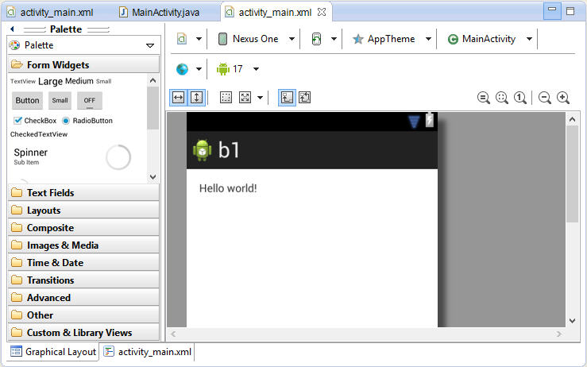

**Fig 2.1 Graphical Layout**

* **Activity_main.xml**

<RelativeLayout xmlns:android=*"http://schemas.android.com/apk/res/android"*

xmlns:tools=*"http://schemas.android.com/tools"*

android:layout_width=*"match_parent"*

android:layout_height=*"match_parent"*

android:paddingBottom=*"@dimen/activity_vertical_margin"*

android:paddingLeft=*"@dimen/activity_horizontal_margin"*

android:paddingRight=*"@dimen/activity_horizontal_margin"*

android:paddingTop=*"@dimen/activity_vertical_margin"*

tools:context=*".MainActivity"* >

<TextView

android:layout_width=*"wrap_content"*

android:layout_height=*"wrap_content"*

android:text=*"@string/hello_world"* />

</RelativeLayout>

* **MainActivity.java**

package com.example.b1;

import android.os.Bundle;

import android.app.Activity;

import android.view.Menu;

public class MainActivity extends Activity {

@Override

protected void onCreate(Bundle savedInstanceState) {

super.onCreate(savedInstanceState);

setContentView(R.layout.activity_main);

}

@Override

public boolean onCreateOptionsMenu(Menu menu) {

// Inflate the menu; this adds items to the action bar if it is present.

getMenuInflater().inflate(R.menu.main, menu);

return true;

}

}

Output

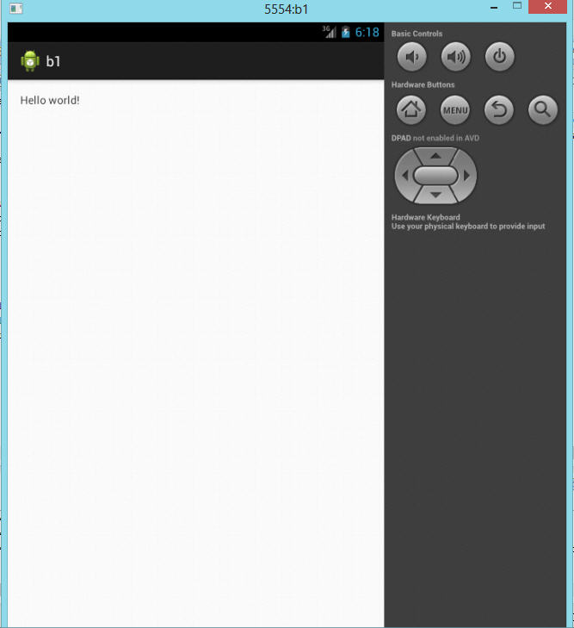

**Fig 2.3 Output Window**

**PRACTICAL-3**

**AIM: Create an Android application to check which button you have clicked.**

Graphical Layout

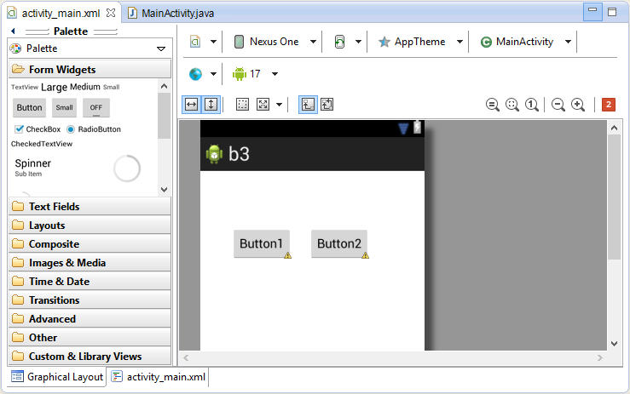

**Fig 3.1 Graphical Layout**

* **Activity_main.xml**

<RelativeLayout xmlns:android=*"http://schemas.android.com/apk/res/android"*

xmlns:tools=*"http://schemas.android.com/tools"*

android:layout_width=*"match_parent"*

android:layout_height=*"match_parent"*

android:paddingBottom=*"@dimen/activity_vertical_margin"*

android:paddingLeft=*"@dimen/activity_horizontal_margin"*

android:paddingRight=*"@dimen/activity_horizontal_margin"*

android:paddingTop=*"@dimen/activity_vertical_margin"*

tools:context=*".MainActivity"* >

<Button

android:id=*"@+id/button2"*

android:layout_width=*"wrap_content"*

android:layout_height=*"wrap_content"*

android:layout_alignBaseline=*"@+id/button1"*

android:layout_alignBottom=*"@+id/button1"*

android:layout_marginLeft=*"23dp"*

android:layout_toRightOf=*"@+id/button1"*

android:onClick=*"onMyButton2Click"*

android:text=*"Button2"* />

<Button

android:id=*"@+id/button1"*

android:layout_width=*"wrap_content"*

android:layout_height=*"wrap_content"*

android:layout_alignParentLeft=*"true"*

android:layout_alignParentTop=*"true"*

android:layout_marginLeft=*"28dp"*

android:layout_marginTop=*"64dp"*

android:onClick=*"onMyButton1Click"*

android:text=*"Button1"* />

</RelativeLayout>

* **MainActivity.java**

package com.example.b3;

import android.os.Bundle;

import android.app.Activity;

import android.view.Menu;

import android.view.View;

import android.widget.Toast;

public class MainActivity extends Activity {

@Override

protected void onCreate(Bundle savedInstanceState) {

super.onCreate(savedInstanceState);

setContentView(R.layout.activity_main);

}

@Override

public boolean onCreateOptionsMenu(Menu menu) {

// Inflate the menu; this adds items to the action bar if it is present.

getMenuInflater().inflate(R.menu.main, menu);

return true;

}

public void onMyButton2Click(View view)

{

Toast.makeText(this, "Button 2 clicked!", Toast.LENGTH_SHORT).show();

}

public void onMyButton1Click(View view)

{

Toast.makeText(this, "Button 1 clicked!", Toast.LENGTH_SHORT).show();

}

}

Output:

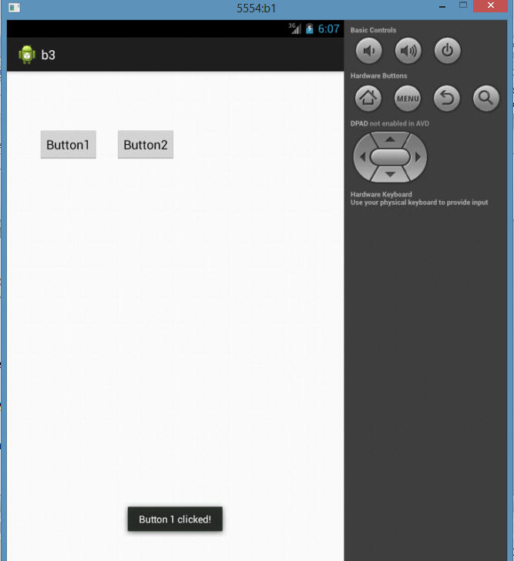

**Fig 3.3 Output Window 1**

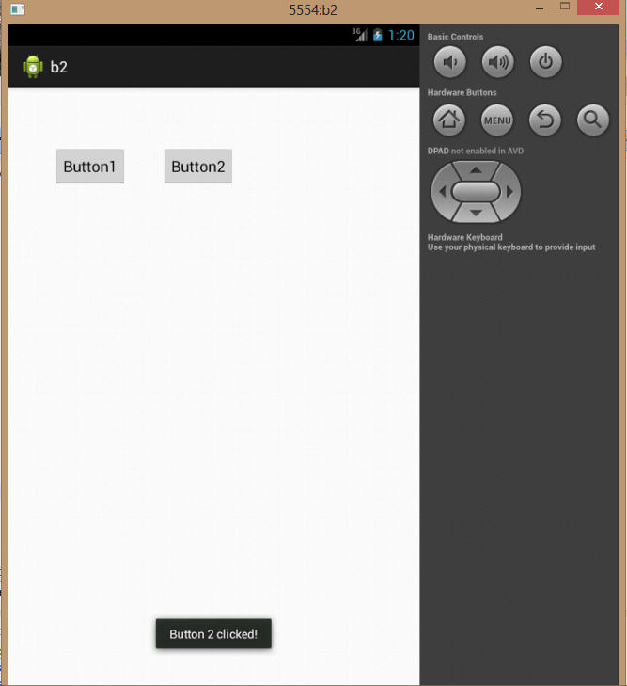

**Fig 3.4 Output Window 2**

**PRACTICAL-4**

**AIM: Create a Dialog Box in Android.**

Graphical Layout

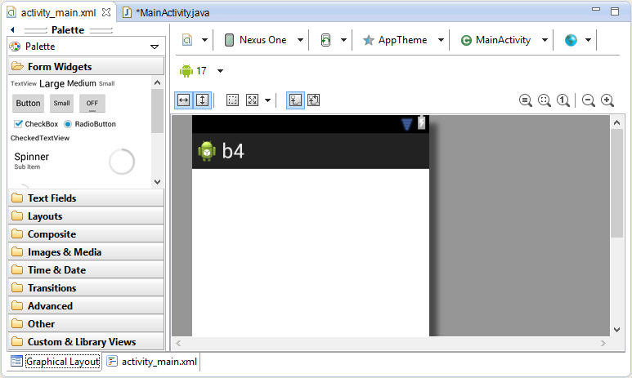

**Fig 4.1 Graphical Layout**

* **Activity_main.xml**

<RelativeLayoutxmlns:android=*"http://schemas.android.com/apk/res/android"*

xmlns:tools=*"http://schemas.android.com/tools"*

android:layout_width=*"match_parent"*

android:layout_height=*"match_parent"*

android:paddingBottom=*"@dimen/activity_vertical_margin"*

android:paddingLeft=*"@dimen/activity_horizontal_margin"*

android:paddingRight=*"@dimen/activity_horizontal_margin"*

android:paddingTop=*"@dimen/activity_vertical_margin"*

tools:context=*".MainActivity"*>

</RelativeLayout>

* **MainActivity.java**

**package** com.example.b4;

**import** android.os.Bundle;

**import** android.app.Activity;

**import** android.app.AlertDialog;

**import** android.content.DialogInterface;

**import** android.view.Menu;

**import** android.widget.Toast;

**publicclass** MainActivity **extends** Activity

{

**protectedvoid** onCreate(Bundle savedInstanceState)

{

**super**.onCreate(savedInstanceState);

setContentView(R.layout.*activity_main*);

AlertDialog.Builder adb=**new** AlertDialog.Builder(**this**);

adb.setTitle("Alert Dialog...");

adb.setMessage("Are You Sure?");

adb.setPositiveButton("Yes",**new** DialogInterface.OnClickListener()

{

**publicvoid** onClick(DialogInterface arg0, **int** arg1)

{

Toast.*makeText*(getApplicationContext(), "You Pressed Yes..", Toast.*LENGTH_LONG*).show();

}

});

adb.setNegativeButton("No",**new** DialogInterface.OnClickListener()

{

**publicvoid** onClick(DialogInterface arg0, **int** arg1)

{

Toast.*makeText*(getApplicationContext(), "You Pressed No..", Toast.*LENGTH_LONG*).show();

}

});

adb.show();

}

**publicboolean** onCreateOptionsMenu(Menu menu)

{

getMenuInflater().inflate(R.menu.*main*, menu);

**returntrue**;

}

Output

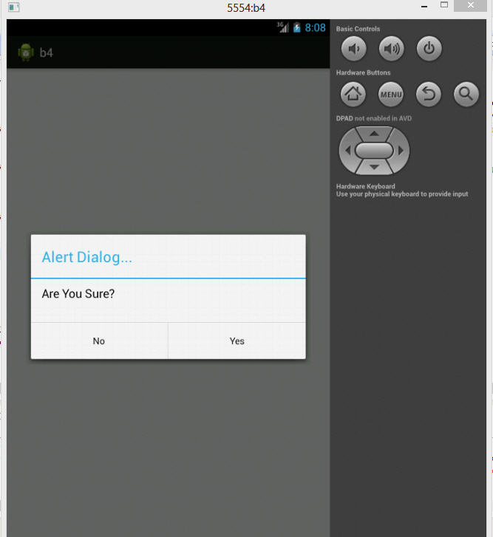

**Fig 4.2.1 Output Window**

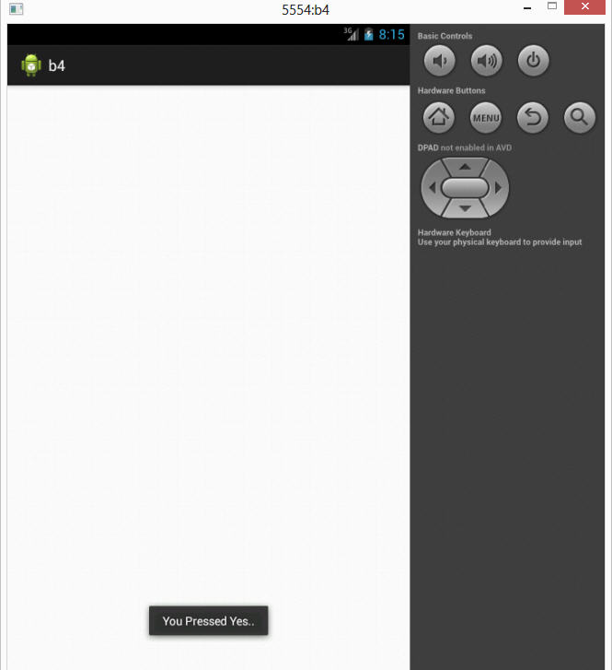

**Fig 4.2.2 Output Window**

**PRACTICAL-5**

**AIM: Generate a simple Calculator.**

Graphical Layout

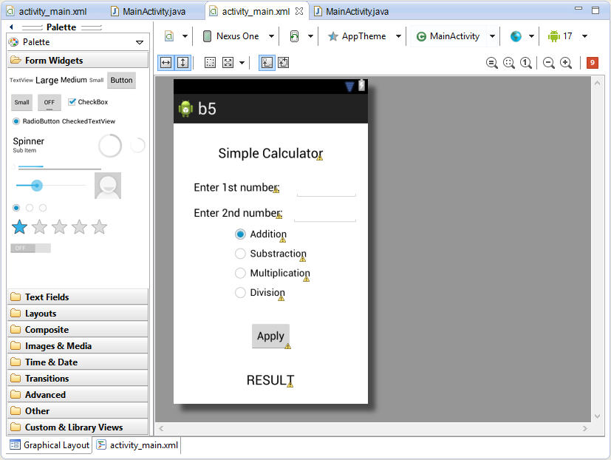

**Fig 5.1 Graphical Layout**

* **Activity_main.xml**

<RelativeLayoutxmlns:android=*"http://schemas.android.com/apk/res/android"*

xmlns:tools=*"http://schemas.android.com/tools"*

android:layout_width=*"match_parent"*

android:layout_height=*"match_parent"*

android:paddingBottom=*"@dimen/activity_vertical_margin"*

android:paddingLeft=*"@dimen/activity_horizontal_margin"*

android:paddingRight=*"@dimen/activity_horizontal_margin"*

android:paddingTop=*"@dimen/activity_vertical_margin"*

tools:context=*".MainActivity"*>

<RadioGroup

android:id=*"@+id/radioGroup1"*

android:layout_width=*"wrap_content"*

android:layout_height=*"wrap_content"*

android:layout_centerHorizontal=*"true"*

android:layout_centerVertical=*"true"*>

<RadioButton

android:id=*"@+id/add"*

android:layout_width=*"wrap_content"*

android:layout_height=*"wrap_content"*

android:checked=*"true"*

android:text=*"Addition"*/>

<RadioButton

android:id=*"@+id/sub"*

android:layout_width=*"wrap_content"*

android:layout_height=*"wrap_content"*

android:text=*"Substraction"*/>

<RadioButton

android:id=*"@+id/mul"*

android:layout_width=*"wrap_content"*

android:layout_height=*"wrap_content"*

android:text=*"Multiplication"*/>

<RadioButton

android:id=*"@+id/div"*

android:layout_width=*"wrap_content"*

android:layout_height=*"wrap_content"*

android:text=*"Division"*/>

</RadioGroup>

<TextView

android:id=*"@+id/textView4"*

android:layout_width=*"wrap_content"*

android:layout_height=*"wrap_content"*

android:layout_alignParentTop=*"true"*

android:layout_centerHorizontal=*"true"*

android:layout_marginTop=*"20dp"*

android:text=*"Simple Calculator"*

android:textAppearance=*"?android:attr/textAppearanceLarge"*/>

<TextView

android:id=*"@+id/textView1"*

android:layout_width=*"wrap_content"*

android:layout_height=*"wrap_content"*

android:layout_above=*"@+id/editText2"*

android:layout_alignRight=*"@+id/button1"*

android:layout_marginBottom=*"14dp"*

android:layout_marginRight=*"19dp"*

android:text=*"Enter 1st number:"*

android:textAppearance=*"?android:attr/textAppearanceMedium"*/>

<EditText

android:id=*"@+id/editText1"*

android:layout_width=*"wrap_content"*

android:layout_height=*"wrap_content"*

android:layout_alignBaseline=*"@+id/textView1"*

android:layout_alignBottom=*"@+id/textView1"*

android:layout_alignRight=*"@+id/editText2"*

android:layout_toRightOf=*"@+id/textView3"*

android:ems=*"10"*

android:inputType=*"number"*/>

<TextView

android:id=*"@+id/textView3"*

android:layout_width=*"wrap_content"*

android:layout_height=*"wrap_content"*

android:layout_below=*"@+id/button1"*

android:layout_centerHorizontal=*"true"*

android:layout_marginTop=*"35dp"*

android:text=*"RESULT"*

android:textAppearance=*"?android:attr/textAppearanceLarge"*/>

<TextView

android:id=*"@+id/textView2"*

android:layout_width=*"wrap_content"*

android:layout_height=*"wrap_content"*

android:layout_alignBaseline=*"@+id/editText2"*

android:layout_alignBottom=*"@+id/editText2"*

android:layout_alignLeft=*"@+id/textView1"*

android:text=*"Enter 2nd number:"*

android:textAppearance=*"?android:attr/textAppearanceMedium"*/>

<EditText

android:id=*"@+id/editText2"*

android:layout_width=*"wrap_content"*

android:layout_height=*"wrap_content"*

android:layout_above=*"@+id/radioGroup1"*

android:layout_toRightOf=*"@+id/textView1"*

android:ems=*"10"*

android:inputType=*"number"*/>

<Button

android:id=*"@+id/button1"*

android:layout_width=*"wrap_content"*

android:layout_height=*"wrap_content"*

android:layout_below=*"@+id/radioGroup1"*

android:layout_centerHorizontal=*"true"*

android:layout_marginTop=*"31dp"*

android:text=*"Apply"*/>

</RelativeLayout>

* **MainActivity.java**

**package** com.example.b5;

**import android**.os.Bundle;

**import android**.app.Activity;

**import android**.view.Menu;

**import android**.view.View;

**import android**.view.View.OnClickListener;

**import android**.widget.Button;

**import android**.widget.*;

**import android**.widget.TextView;

**import android**.widget.Toast;

**public class** MainActivity **extends** Activity

{

**Protected void** onCreate(Bundle savedInstanceState)

{

**super**.onCreate(savedInstanceState);

setContentView(R.layout.*activity_main*);

**final** EditText num1=(EditText)findViewById(R.id.*editText1*);

**final** EditText num2=(EditText)findViewById(R.id.*editText2*);

**final** TextView result=(TextView)findViewById(R.id.*textView3*);

**final** RadioGrouprg=(RadioGroup)findViewById(R.id.*radioGroup1*);

**final** Button b1=(Button)findViewById(R.id.*button1*);

b1.setOnClickListener(**new**OnClickListener()

{

**Public void**onClick(View arg0)

{

**if**(num1.getText().toString().isEmpty() || num2.getText().toString().isEmpty())

{

Toast.*makeText*(getApplicationContext(), "Please Enter Values..", Toast.*LENGTH_LONG*).show();

}

**else**

{

Double n1=Double.*parseDouble*(num1.getText().toString());

Double n2=Double.*parseDouble*(num2.getText().toString());

**Int** selectoperation=rg.getCheckedRadioButtonId();

RadioButton op=(RadioButton)findViewById(selectoperation);

String s=newString(op.getText().toString());

if(s.equals("Addition"))

{

result.setText(String.valueOf(n1+n2));

}

elseif(s.equals("Substraction"))

{

result.setText(String.valueOf(n1-n2));

}

elseif(s.equals("Multiplication"))

{

result.setText(String.valueOf(n1*n2));

}

elseif(s.equals("Division"))

{

if(n2==0)

{

result.setText("DIVIDE BY 0 ERROR!!!");

}

else

{

result.setText(String.valueOf(n1/n2));

}

}

}

}

});

}

Public booleanon Create OptionsMenu(Menu menu) {

getMenuInflater().inflate(R.menu.main, menu);

return true;

}

}

Output

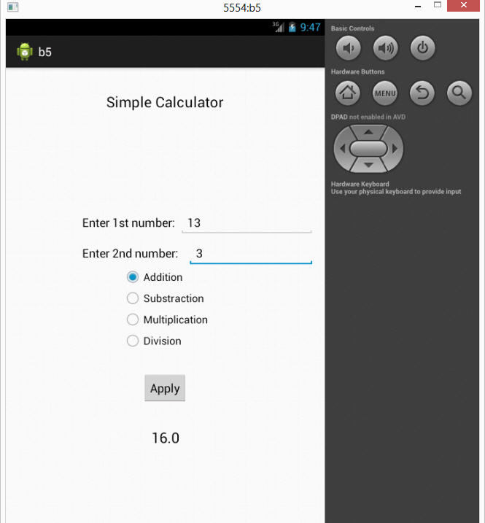

**Fig 5.2.1 Output Window Addition**

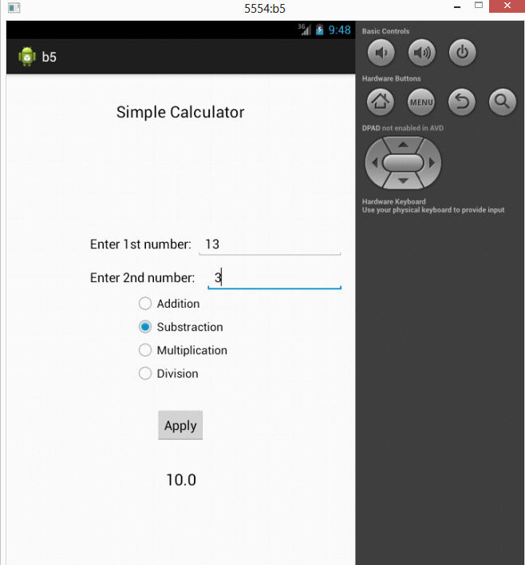

**Fig 5.2.2 Output Window Subtraction**

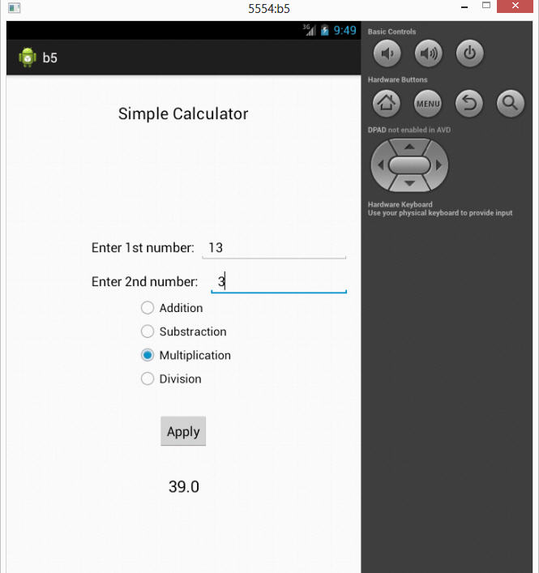

**Fig 5.2.3 Output Window Multiplication**

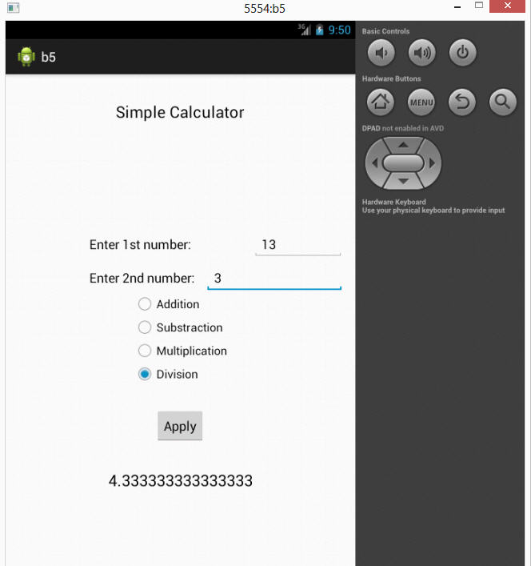

**Fig 5.2.4 Output Window Division**

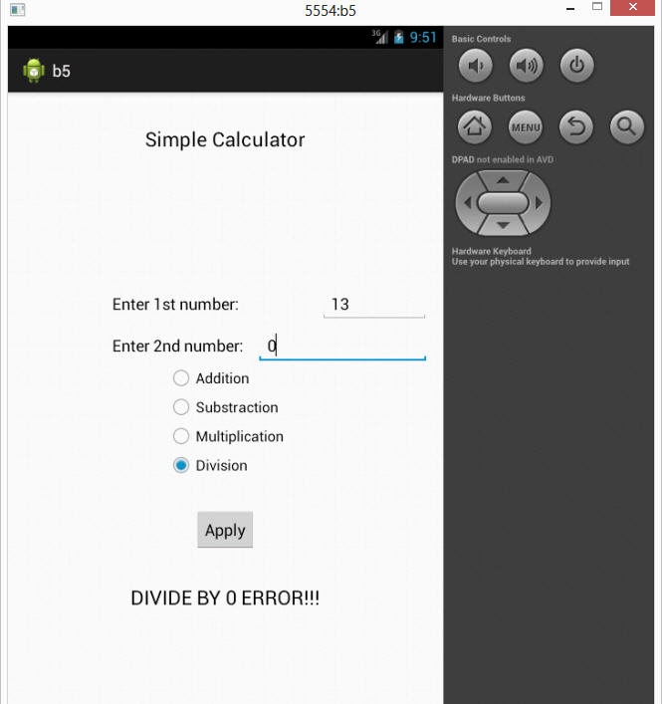

**Fig 5.2.5 Output Window Divide/0**

**PRACTICAL - 6**

**AIM: Create an android application that contains multiple tabs.**

* **MainActivity.java**

package com.example.tabapp1;

import android.os.Bundle;

import android.app.Activity;

import android.view.Menu;

import android.widget.TabHost;

import android.widget.TabHost.TabSpec;

public class MainActivity extends Activity {

@Override

protected void onCreate(Bundle savedInstanceState) {

super.onCreate(savedInstanceState);

setContentView(R.layout.activity_main);

TabHost tbhst1=(TabHost)findViewById(android.R.id.tabhost);

tbhst1.setup();

TabSpec spec1=tbhst1.newTabSpec("Tab 11");

spec1.setIndicator("ANALOG CLOCK");

spec1.setContent(R.id.analogClock1);

TabSpec spec2=tbhst1.newTabSpec("Tab 22");

spec2.setIndicator("DIGITAL CLOCK");

spec2.setContent(R.id.digitalClock1);

tbhst1.addTab(spec1);

tbhst1.addTab(spec2);

}

@Override

public boolean onCreateOptionsMenu(Menu menu) {

// Inflate the menu; this adds items to the action bar if it is present.

getMenuInflater().inflate(R.menu.main, menu);

return true;

}

}

* **Activity_main.xml**

<RelativeLayout xmlns:android=*"http://schemas.android.com/apk/res/android"*

xmlns:tools=*"http://schemas.android.com/tools"*

android:layout_width=*"match_parent"*

android:layout_height=*"match_parent"*

android:paddingBottom=*"@dimen/activity_vertical_margin"*

android:paddingLeft=*"@dimen/activity_horizontal_margin"*

android:paddingRight=*"@dimen/activity_horizontal_margin"*

android:paddingTop=*"@dimen/activity_vertical_margin"*

tools:context=*".MainActivity"* >

<TabHost

android:id=*"@android:id/tabhost"*

android:layout_width=*"match_parent"*

android:layout_height=*"match_parent"*

android:layout_alignParentLeft=*"true"*

android:layout_alignParentTop=*"true"* >

<LinearLayout

android:layout_width=*"match_parent"*

android:layout_height=*"match_parent"*

android:orientation=*"vertical"* >

<TabWidget

android:id=*"@android:id/tabs"*

android:layout_width=*"match_parent"*

android:layout_height=*"wrap_content"* >

</TabWidget>

<FrameLayout

android:id=*"@android:id/tabcontent"*

android:layout_width=*"match_parent"*

android:layout_height=*"match_parent"* >

<LinearLayout

android:id=*"@+id/tab1"*

android:layout_width=*"match_parent"*

android:layout_height=*"match_parent"* >

<AnalogClock

android:id=*"@+id/analogClock1"*

android:layout_width=*"wrap_content"*

android:layout_height=*"wrap_content"* />

</LinearLayout>

<LinearLayout

android:id=*"@+id/tab2"*

android:layout_width=*"match_parent"*

android:layout_height=*"match_parent"*

tools:ignore=*"Orientation"* >

<DigitalClock

android:id=*"@+id/digitalClock1"*

android:layout_width=*"wrap_content"*

android:layout_height=*"wrap_content"*

android:text=*"DigitalClock"*

tools:ignore=*"HardcodedText"* />

</LinearLayout>

</FrameLayout>

</LinearLayout>

</TabHost>

</RelativeLayout>

Output:

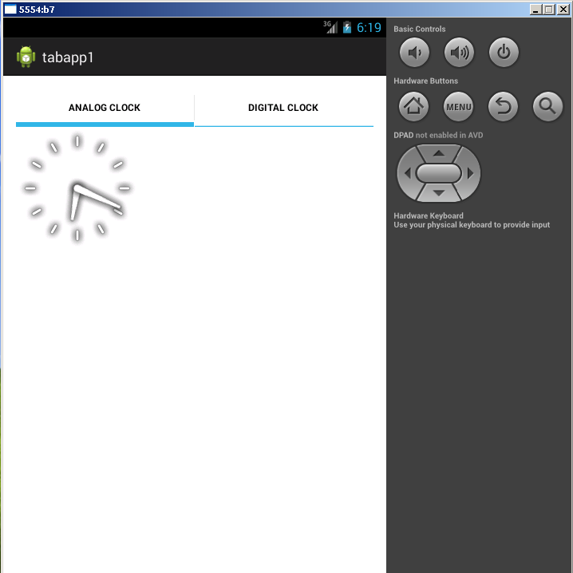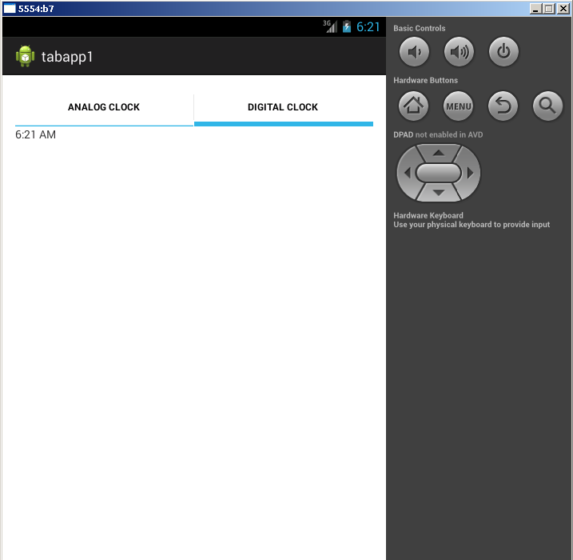

**PRACTICAL – 7**

**AIM: Create listview with multiple choice in android.**

* **Activity_main.xml**

<manifest xmlns:android="http://schemas.android.com/apk/res/android"

package="com.example.listviewexample"

android:versionCode="1"

android:versionName="1.0" >

<uses-sdk

android:minSdkVersion="8"

android:targetSdkVersion="15" />

<application

android:icon="@drawable/ic_launcher"

android:label="@string/app_name"

android:theme="@style/AppTheme" >

<activity

android:name=".MainActivity"

android:label="@string/title_activity_main" >

<intent-filter>

<action android:name="android.intent.action.MAIN" />

<category android:name="android.intent.category.LAUNCHER" />

</intent-filter>

</activity>

</application>

</manifest>

* **MainActivity.java**

import android.app.ListActivity;

import android.os.Bundle;

import android.view.ActionMode;

import android.view.Menu;

import android.view.MenuInflater;

import android.view.MenuItem;

import android.view.View;

import android.widget.AdapterView;

import android.widget.AdapterView.OnItemLongClickListener;

import android.widget.Toast;

public class MyListActivityActionbar extends ListActivity {

protected Object mActionMode;

public int selectedItem = -1;

public void onCreate(Bundle icicle) {

super.onCreate(icicle);

setContentView(R.layout.main);

String[] values = new String[] { “Mercury",”Venus”,”Mars”,”Jupiter”,”Saturn”,”Uranus”,”Neptune”};

MySimpleArrayAdapter adapter = new MySimpleArrayAdapter(this, values);

setListAdapter(adapter);

getListView().setOnItemLongClickListener(new OnItemLongClickListener() {

@Override

public boolean onItemLongClick(AdapterView<?> parent, View view,

int position, long id) {

if (mActionMode != null) {

return false;

}

selectedItem = position;

mActionMode = MyListActivityActionbar.this

.startActionMode(mActionModeCallback);

view.setSelected(true);

return true;

}

});

}

private ActionMode.Callback mActionModeCallback = new ActionMode.Callback() {

public boolean onCreateActionMode(ActionMode mode, Menu menu) {

MenuInflater inflater = mode.getMenuInflater();

inflater.inflate(R.menu.rowselection, menu);

return true;

}

public boolean onPrepareActionMode(ActionMode mode, Menu menu) {

return false; // Return false if nothing is done

}

public boolean onActionItemClicked(ActionMode mode, MenuItem item) {

switch (item.getItemId()) {

case R.id.menuitem1_show:

show();

mode.finish();

return true;

default:

return false;

}

}

public void onDestroyActionMode(ActionMode mode) {

mActionMode = null;

selectedItem = -1;

}

};

private void show() {

Toast.makeText(MyListActivityActionbar.this,

String.valueOf(selectedItem), Toast.LENGTH_LONG).show();

}

}

OUTPUT

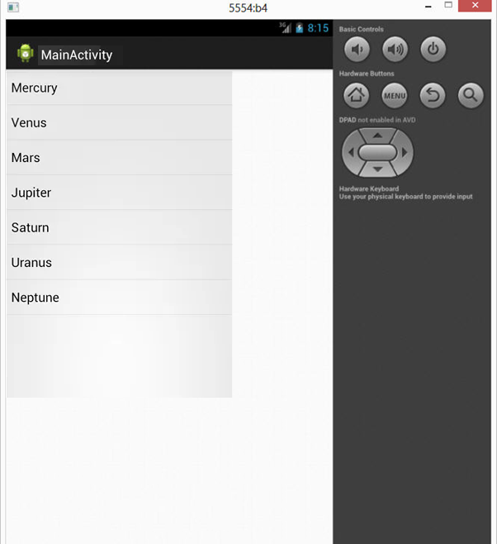

**Figure 7.1 – ListView**

**PRACTICAL – 8**

**AIM: Create an application in android for slideshow animation.**

Graphical Layout

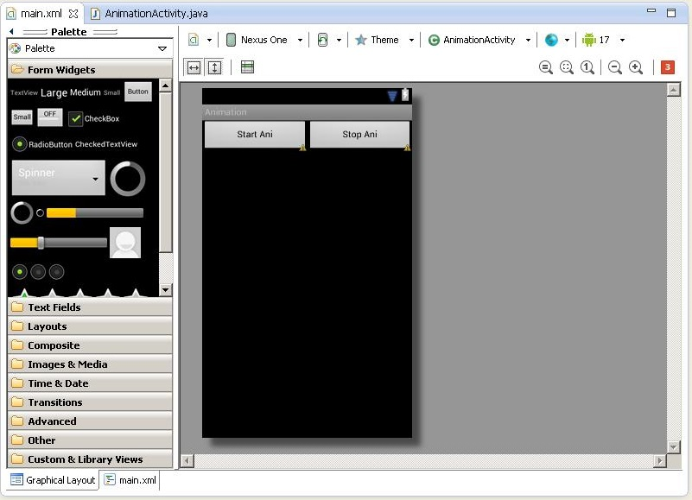

**Figure 8.1 – Main layout**

* **Activity_main.xml**

<?xml version="1.0" encoding="utf-8"?>

<TableLayout android:id="@+id/TableLayout1" xmlns:android="http://schemas.android.com/apk/res/android"

android:layout_width="fill_parent"

android:layout_height="fill_parent"

>

<TableRow android:id="@+id/tableRow1" android:layout_width="wrap_content" android:layout_height="wrap_content">

<Button

android:id="@+id/button1"

android:layout_width="wrap_content"

android:layout_height="wrap_content"

android:layout_weight="1"

android:text="Start Ani" >

</Button>

<Button

android:id="@+id/button2"

android:layout_width="wrap_content"

android:layout_height="wrap_content"

android:layout_weight="1"

android:text="Stop Ani" >

</Button>

</TableRow>

<ImageView android:layout_height="wrap_content" android:id="@+id/imageView1" android:layout_width="wrap_content"></ImageView>

</TableLayout>

* **MainActivity.java**

package sl.mc;

import android.app.Activity;

import android.graphics.drawable.AnimationDrawable;

import android.os.Bundle;

import android.view.View;

import android.view.View.OnClickListener;

import android.widget.Button;

import android.widget.ImageView;

public class AnimationActivity extends Activity {

Button b1,b2;

ImageView i1;

AnimationDrawable ad;

@Override

public void onCreate(Bundle savedInstanceState) {

super.onCreate(savedInstanceState);

setContentView(R.layout.main);

b1=(Button)findViewById(R.id.button1);

b2=(Button)findViewById(R.id.button2);

i1=(ImageView)findViewById(R.id.imageView1);

i1.setBackgroundResource(R.drawable.framebyframe);

b1.setOnClickListener(new OnClickListener() {

public void onClick(View arg0) {

ad=(AnimationDrawable)i1.getBackground();

ad.start();

}

});

b2.setOnClickListener(new OnClickListener() {

public void onClick(View arg0) {

.stop();

}

});

}

}

OUTPUT

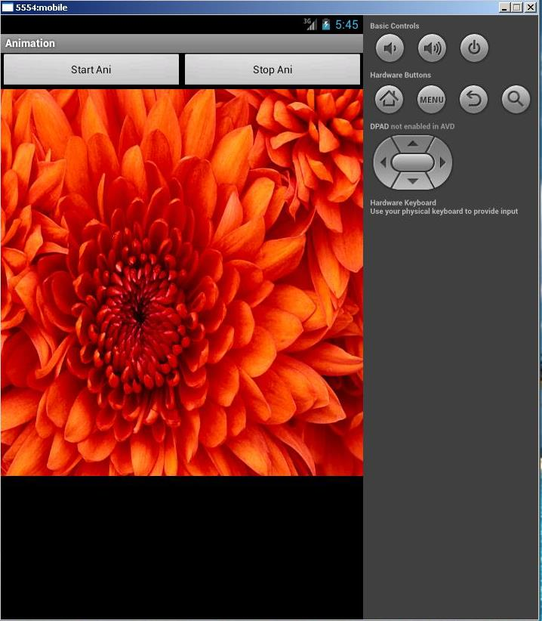

**Figure 8.2.1 - First Slide**

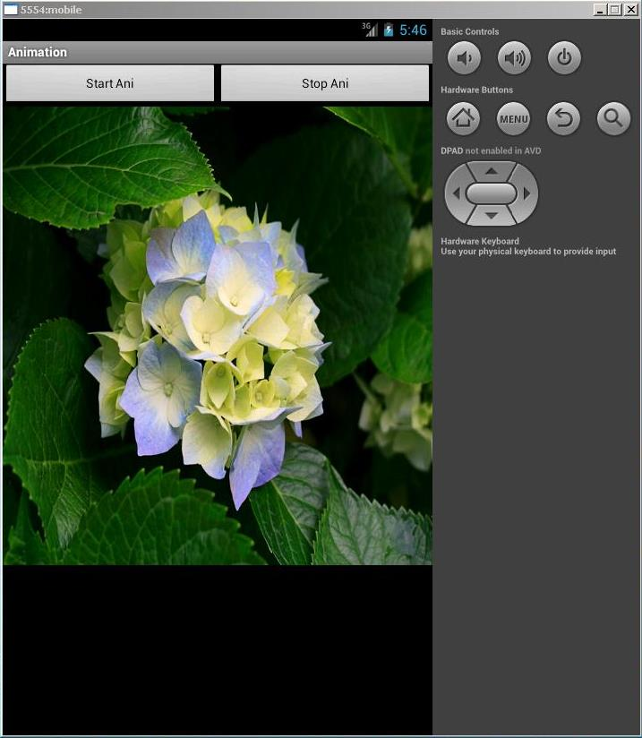

**Figure 8.2.2 – Second Slide**

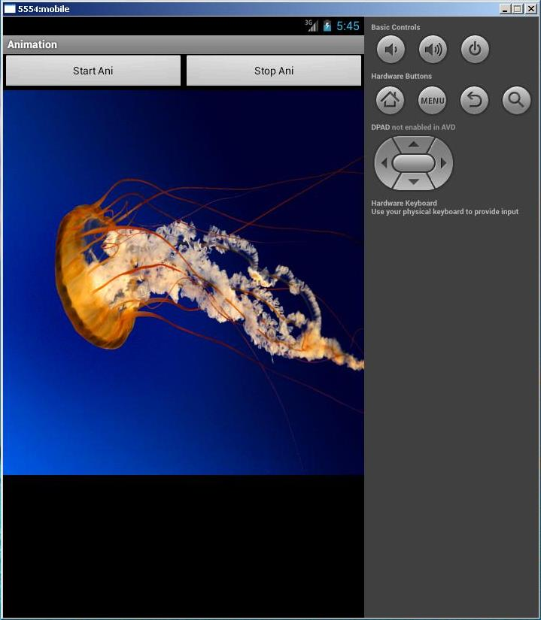

**Figure 8.2.3 - Third Slide**

**PRACTICAL – 9**

**AIM: Create an application in android to find factorial of a number using OnClick event.**

Graphical Layout

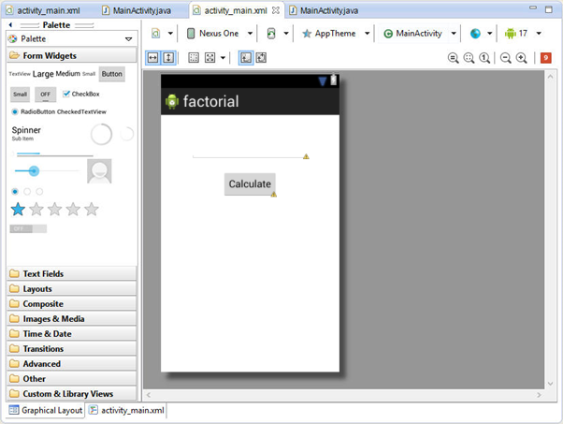

* **Activity_main.xml**

<LinearLayout xmlns:android="http://schemas.android.com/apk/res/android"

android:layout_width="fill_parent"

android:layout_height="fill_parent"

android:orientation="vertical" >

<TextView

android:id="@+id/txtView"

android:layout_width="150dp"

android:layout_height="150dp"

android:text="@string/hello" />

<Button

android:id="@+id/mybtn"

android:layout_width="50dp"

android:layout_height="30dp" />

<TextView

android:id="@+id/viewwidth"

android:layout_width="fill_parent"

android:layout_height="wrap_content" />

<TextView

android:id="@+id/viewheight"

android:layout_width="fill_parent"

android:layout_height="wrap_content" />

</LinearLayout>

* **MainActivity.java**

import android.app.Activity;

import android.os.Bundle;

import android.view.View;

import android.widget.Button;

import android.widget.EditText;

import android.widget.TextView;

import com.droidacid.apticalc.R;

public class AptiFactorial extends Activity implements android.view.View.OnClickListener{

EditText number;

TextView answer;

Button calculate;

@Override

protected void onCreate(Bundle savedInstanceState) {

super.onCreate(savedInstanceState);

setContentView(R.layout.apti_factorial);

initialize();

}

private void initialize() {

number = (EditText) findViewById(R.id.et_apti_number);

number.setHint("Enter number to be factorialized :P")

answer = (TextView) findViewById(R.id.tv_apti_answer);

calculate = (Button) findViewById(R.id.b_apti_calc);

calculate.setOnClickListener(this);

}

private long calcFactorial() {

long factorial = 1;

try {

factorial = Long.parseLong(number.getText().toString());

for(int i=factorial-1; i>0; i--){

factorial = i * factorial;

}

} catch (NumberFormatException e) {

Toast.makeText(this, "Incorrect Input", Toast.LENGTH_LONG).show();

} finally {}

return factorial;

}

@Override

public void onClick(View v) {

answer.setText("Factorial of " + number.getText().toString() + " is : " + calcFactorial());

}

OUTPUT

